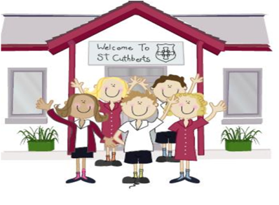333333333333 22nd April 2022

FRIDAY NEWSLETTER

3rd

Reception 67%

Year 1 100%

Year 2 96%

Year 3 100%

Year 4 100%

Year 5 87%

Year 6 100%

**DIARY - KEY DATES:**

* Whole school Forest schools – Tuesday 17th May
* Year 5 & 6 residential – 19th – 20th May
* First Holy communion club – Thursday 19th May
* First Holy communion - Sunday 22nd May
* KS2 BIG SING - 27th May (during school time)
* PFA Jubilee party - 27th May starting at 2.45pm – parents welcome from 3.15pm

**Hope you all have a lovely weekend!!**

**Wrap-around Care** - all payments are due in advance when booking please

Breakfast Club is open from 8.15am until 8.45am £2 per child, per session

After-school Club* runs from 3.15pm until 5.15 pm at £4 per child, per session.

*Please book a week in advance to allow staff planning. If less notice is given we cannot guarantee availability.

**Our year 6 celebrating a successful week of SAT’s**

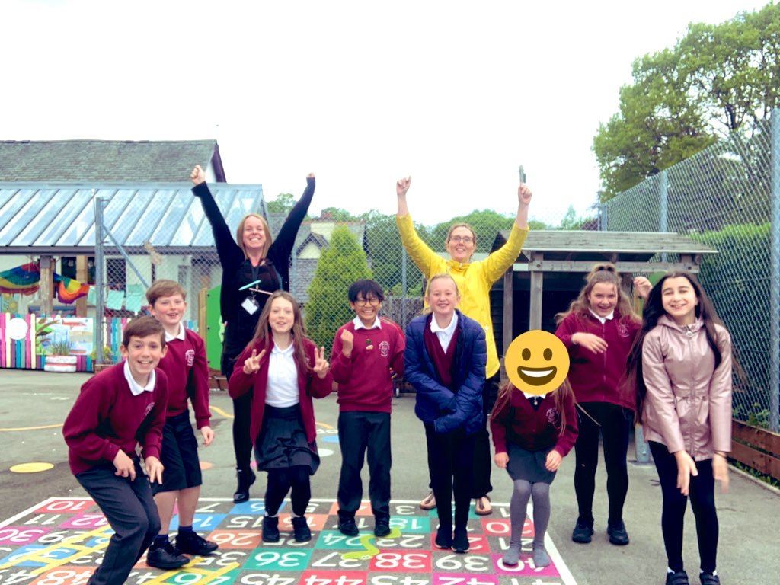

**Head Teacher’s Comments**

Dear Parents and Carers,

We have enjoyed another wonderful week in school. The Year 6's have worked really hard completing their SATs, the first ones since 2019. They definitely deserved their surprises this week. They were treated to waitress service in the lunch hall, a big cake with ice creams on Thursday and on Friday they've hosted a whole KS2 post SATs party. The children enjoyed learning the time warp and superman dance moves...

School welcomed some new pets to add to our ever-growing pet collection this week.

The Explorers have some new pet stick insects, which the children are enjoying learning about and looking after.

A reminder that we have forest schools on Tuesday of next week, arrangements as before. Year 5 and 6 also have their residential on Thursday of next week. We are very excited to be finally planning an overnight trip. The children are so excited!

 You may have seen a new smiling new face in the office; please join us in welcoming Miss Rawlinson to the team. She officially starts in a couple of weeks.

Our group of 14 First Holy Communion children are excited for their celebrations on Sunday 22nd May. The children are also making their sacrament of Reconciliation after mass on Wednesday next week. Thank you to Father Bernard and Mrs Murray for arranging this.

We hope you have a lovely weekend, please keep an eye on the calendar for key dates coming up.

Take care,

Mrs Bone and Mrs Tansey

Stay safe,

Mrs Bone and Mrs Tansey

Mrs Bone and Mrs Tansey

Head of School & Executive Head



WOW! Amazing, year 1 & 4. that’s fantastic!!

Keep

**ATTENDANCE TEDDY AWARD**

