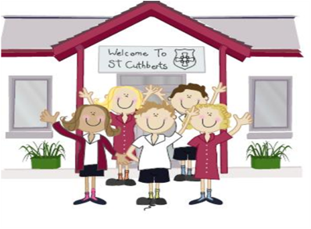333333333333 1st April 2022

**Head Teacher’s Comments**

Dear Parents and Carers,

The holidays are upon us! What a fantastic spring term we have had.

Looking back and reflecting on how much we have achieved and at all the opportunities our children have had is quite remarkable; From wheelchair basketball, forest schools, concerts and sporting events, raising amazing amounts of money for various charities to being given the accolade of the 'second best Primary School in Cumbria' and receiving a magnificent S48 RE inspection -these are just a few of the many things we can be very proud of. We always say that our small size is our strength, and it really is true. Being small (but perfectly formed) means we can give every child the same opportunities regardless of ability.

On Monday, Year 3,4,5 and 6 performed in the Brewery Dance Platform at the Kendal Brewery. The children were absolutely brilliant. They danced superbly and represented our school magnificently. Many thanks to local dance teacher, Nicola Moorhead for choreographing our wonderful Encanto themed dance.

8 KS2 joined other Cumbrian schools for a dodgeball festival on Thursday, the children loved the event, showing great team spirit.

Year 5 had their final forest school session at Brockhole yesterday, many thanks to the LDNPA for funding these engaging and interactive sessions.

Yesterday, Mrs Bone awarded faith awards to the children who entered their lovingly created Easter gardens. Every child was given a chocolate egg for their hard work, it was too tricky to pick an overall winner garden. The Easter Bunny visited school yesterday. Many thanks to the PFA for their ongoing generosity and for treating every child in the school to a special Easter Egg.

Please remember, if you need to book wrap around care, we are requesting you use Lunch shop to book and pay, to keep cash transactions to a minimum.

If we have any parents who speak Ukraine, please let us know.

**School reopens on Wednesday 20th April, we hope you have a lovely and peaceful Easter**

**Break and stay safe,**

Mrs Bone and Mrs Tansey

Head of School & Executive Head





FRIDAY NEWSLETTER

3rd

**Brewery Arts dance performance, well done everyone!**

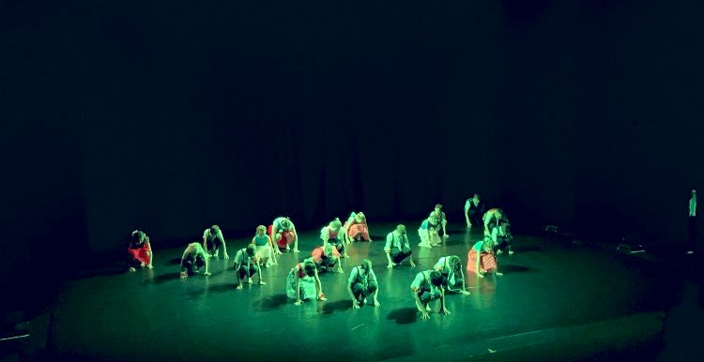

**Well done Team Cuthbert’s happy Easter to you ALL !!**

**ATTENDANCE TEDDY AWARD**



**DIARY – April 2022**

**Tuesday 19th April- inset day.**

**Wednesday 20th School re opens 8. 50 am –**

**Thursday 21st – After school SATs booster (Year 6) club 3.15-4.15 in school**

**Thursday 21st – First Holy Communion Club**

**Friday 17th December – School closed for Christmas.**

**Hope you all have a very merry Christmas!!!!**

**Wrap-around Care** - all payments are due in advance when booking please

Breakfast Club is open from 8.15am until 8.45am £2 per child, per session

After-school Club* runs from 3.15pm until 5.15 pm at £4 per child, per session.

*Please book a week in advance to allow staff planning. If less notice is given we cannot guarantee availability.

Reception 92%

Year 1 91%

Year 2 95%

Year3 94%

Year 4 95%

Year 5 93%

Year 6 92%