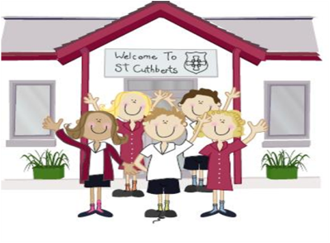333333333333 22nd April 2022

FRIDAY NEWSLETTER

3rd

To help the Queen celebrate her 96th birthday today, we all enjoyed a celebratory ice pop at playtime.

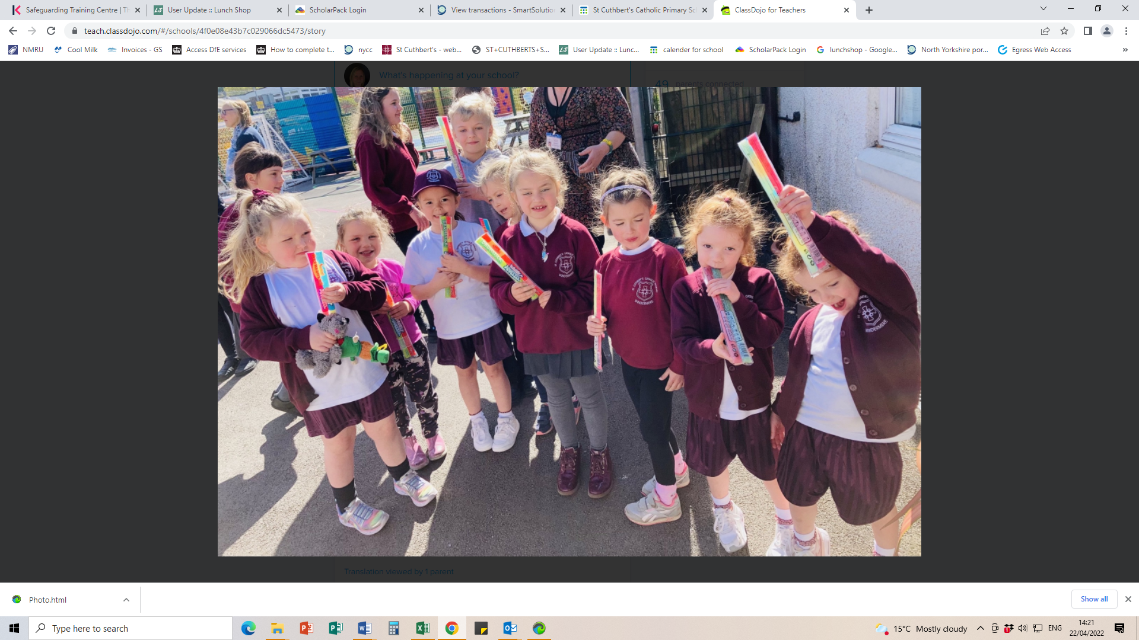

**DIARY – December 2021**

A reminder that we will have to cancel after school club on Tuesday 24th May due to staff training.

**Monday 2nd May** - School closed for bank holiday

**9th May - 12th May -** KS2 SATs week

**Thursdays** - SATs club

**Thursdays** - 1st Holy Communion club

**Friday 27th** - Queens Jubiliee party

**Thursday May 26th** - Open day

Sports day - 1st choice 2nd choice **Wed 8th June / Wed 15th June**

**Hope you all have a lovely weekend!!**

**Wrap-around Care** - all payments are due in advance when booking please

Breakfast Club is open from 8.15am until 8.45am £2 per child, per session

After-school Club* runs from 3.15pm until 5.15 pm at £4 per child, per session.

*Please book a week in advance to allow staff planning. If less notice is given we cannot guarantee availability.

Reception 97%

Year 1 100%

Year 2 94%

Year 3 46%

Year 4 100%

Year 5 91%

Year 6 92%

**Head Teacher’s Comments**

Dear Parents and Carers,

Welcome back to school, we hope you had a peaceful Easter break; the sunshine this week has certainly allowed the children to enjoy playtimes with their friends.

Yesterday we all enjoyed a refreshing ice pop to help us celebrate the Queens 96th birthday.

All children have settled back into their routines and are enjoying their new topics. We have also welcomed 4 new nursery children to our school. As ever our children look after one another and have been making sure our new friends are happy and comfortable in our school.

 We are having an Open day on Thursday May 26th, please spread the word. We currently have spaces in all year groups. Please contact the office for a tour of our amazing school. Cuthbert Bear's baby and toddler group also runs every Thursday, during term time, in the Maryholme centre. 9.30-11.15am. All are welcome.

KS2 enjoyed their first outdoor swim of the year today. Our weekly sessions will run until the end of June. We have swimming hats to buy in the school office.

As per Mrs Bones DOJO message, please could you speak to her or Father Bernard, if you would like your child (Yr 6 and above) to accept the very kind invitation to complete their sacrament of Confirmation. The preparation lessons are weekly, starting this Sunday at 4.15 in Kendal. The celebration would take place on Pentecost Sunday at Lancaster Cathedral. We would like to than Father Hugh for inviting our children to join this celebration.

Please could we remind our parents that wrap around care should be booked and paid for on Lunchshop. The Yr 5/6 residential should also be paid be this way.

Enjoy the weekend and stay safe

Mrs Bone and Mrs Tansey

Stay safe,

Mrs Bone and Mrs Tansey

Mrs Bone and Mrs Tansey

Head of School & Executive Head



WOW! Amazing, year 1 & 4. that’s fantastic!!

Keep

**ATTENDANCE TEDDY AWARD**

