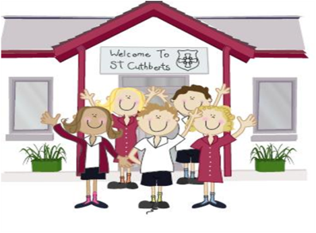333333333333 25th March 2022

**Head Teacher’s Comments**

Dear Parents and Carers,

What a sunny week we have had here at St. Cuthbert's.

The children have certainly enjoyed playtimes!

We are loving all of our play equipment. Hopefully we will have lots of new equipment soon, using the money we raise from our School Council's chocolate tombola.

Yesterday we welcomed Yvonne from Hayes Garden world, who helped us plant lots of spring plants, brightening up our gardens and planters. Thank you to Hayes.

School is looking very colourful and bright, we are hoping to enter Cumbria in Bloom this year.

On Monday our NR,1 and 2 children joined Cumbria Music Hub at Kendal Town Hall, taking part in their L'al sing, performing songs from The Gingerbread man.

We are very proud of how they behaved and sang. Well done Explorers, you represented St. Cuthbert's perfectly.

Year 5's enjoyed their forest school at Brockhole with Jenny from The Lake District National Park authority.

Today, the Mini Police have been out in force. PCSO Sarah Blacow took us onto Lake road with a speed camera. The children loved monitoring the speed of passing cars. Watch your speed!

We are very honoured to be able to share our recent Section 48 RE inspection with you all.

*We would encourage you to visit our website or Facebook page, make a cup of tea and have a read for yourselves.*

**Our overall Effectiveness was graded a 1**, which are extremely proud of.

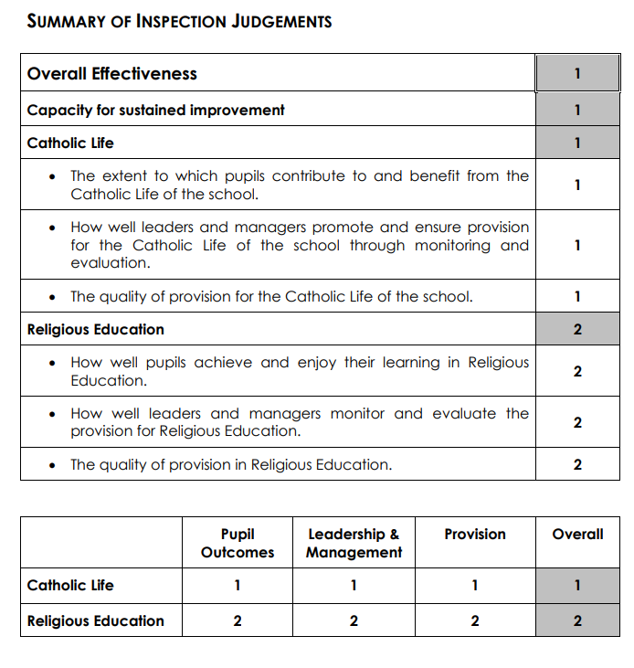 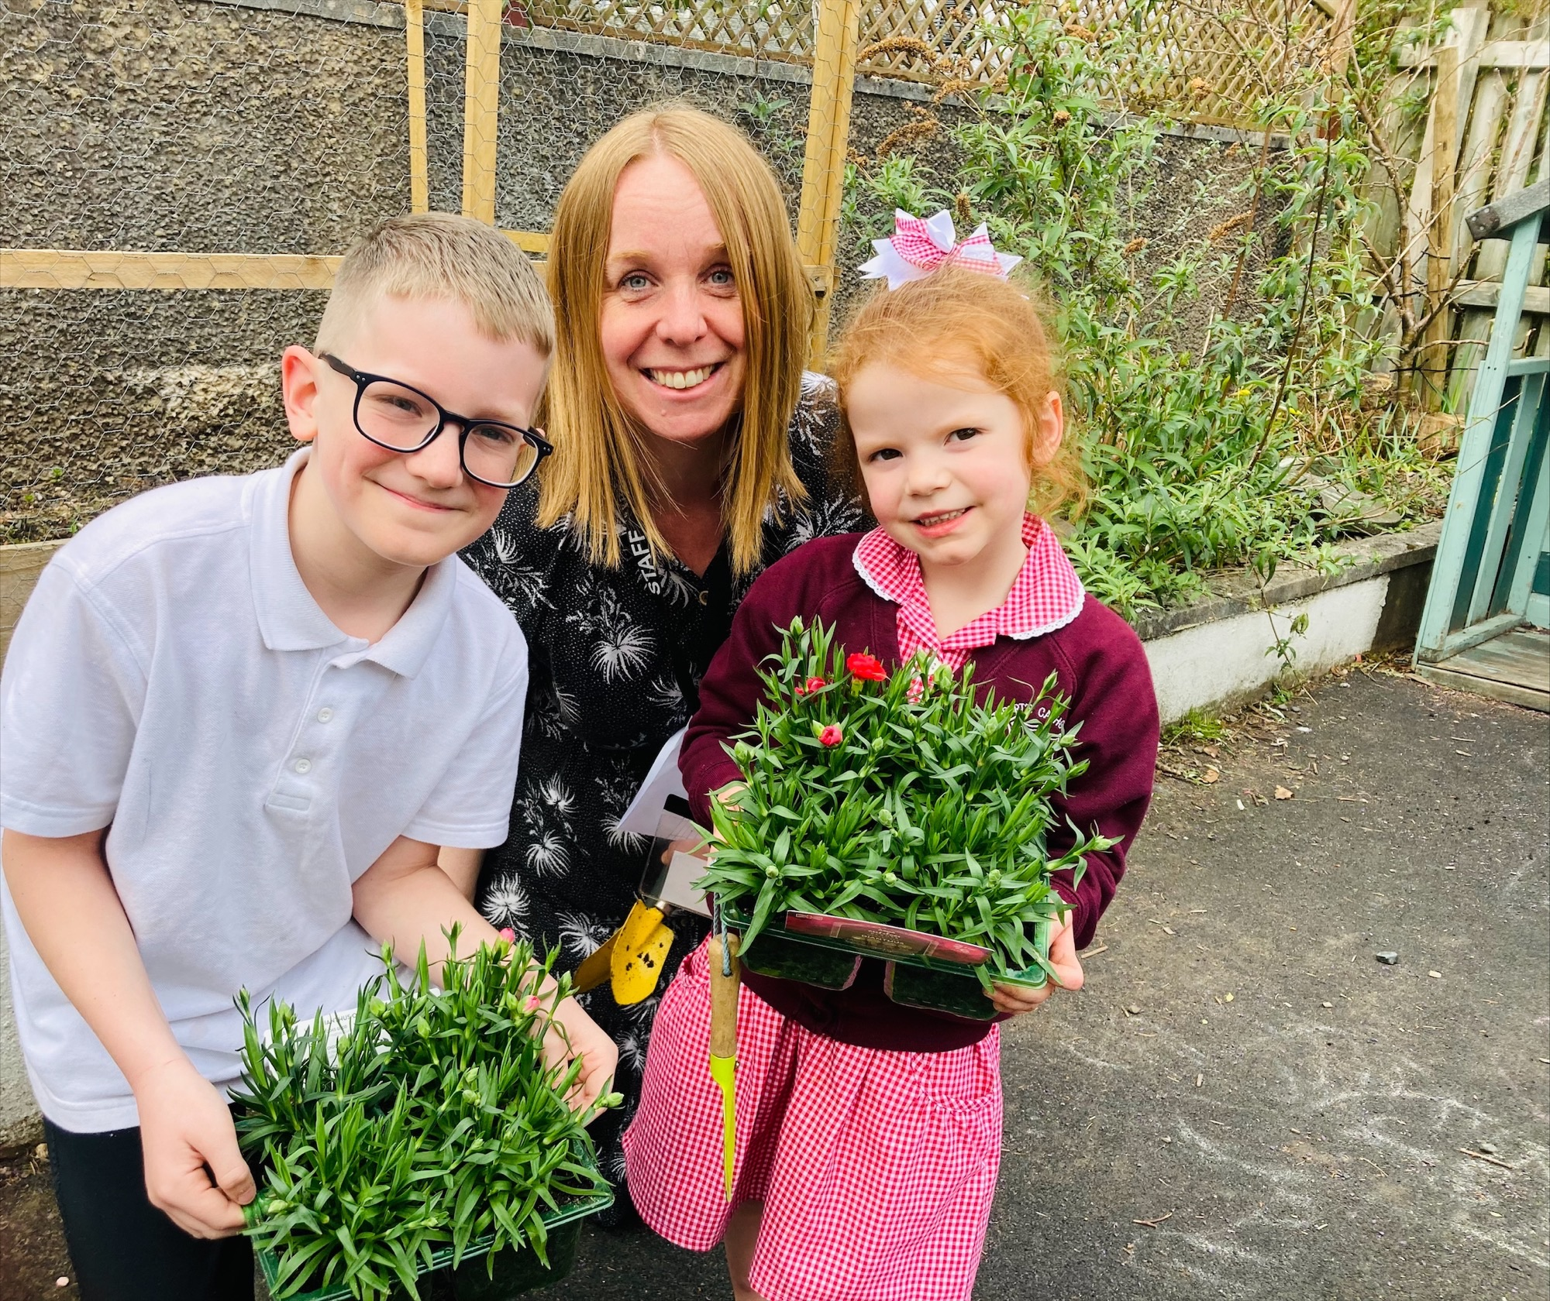

Please remember that closes on Friday 1st April at 2pm. There will be no after school club on this day.

We hope you all have a wonderful weekend, enjoy the sun

Mrs Tansey  Mrs Bone

Executive Head Head of School.

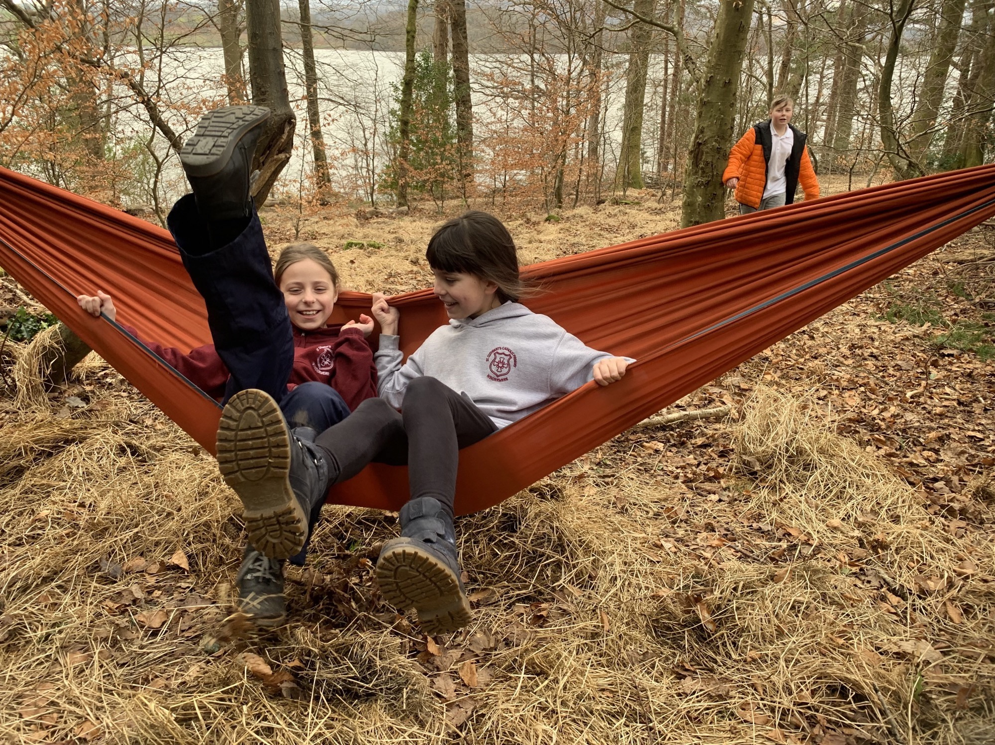



Mrs Bone and Mrs Tansey

Stay safe,

Mrs Bone and Mrs Tansey

Mrs Bone and Mrs Tansey

Head of School & Executive Head



FRIDAY NEWSLETTER

3rd

Yesterday we spent the afternoon planting herbs and flowers kindly donated by Hayes Garden Centre.

**DIARY – March/April 2022**

**Mon 28th Brewery dance performance!**

**Thur 31st March – First Holy Communion preparation 3.15 – 4.15 in school**

**Thur 31st – SATs booster (Year 6) club 3.15-4.15 in school**

**Thursday 31st – Year 5’s forest school at Brockhole**

**Friday 1st April School ends for Easter break @2PM prompt**

**Friday 17th December – School closed for Christmas.**

**Hope you all have a very merry Christmas!!!!**

**Wrap-around Care** - all payments are due in advance when booking please

Breakfast Club is open from 8.15am until 8.45am £2 per child, per session

After-school Club* runs from 3.15pm until 5.15 pm at £4 per child, per session.

*Please book a week in advance to allow staff planning. If less notice is given we cannot guarantee availability.

Reception 90%

Year 1 91%

Year 2 93%

Year3 92%

Year 4 88%

Year 5 91%

Year 6 92%

**ATTENDANCE TEDDY AWARD**



Well done Team Cuthbert’s what an Amazing inspection result!!