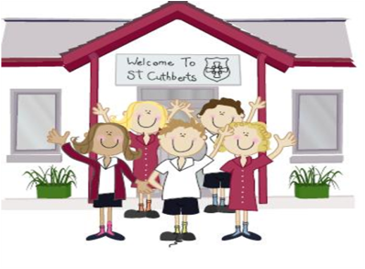33333333333 27th May 2022

FRIDAY NEWSLETTER

3rd

KS2 at The Big Sing at Kendal Town Hall

They performed amazingly and sung their hearts out…

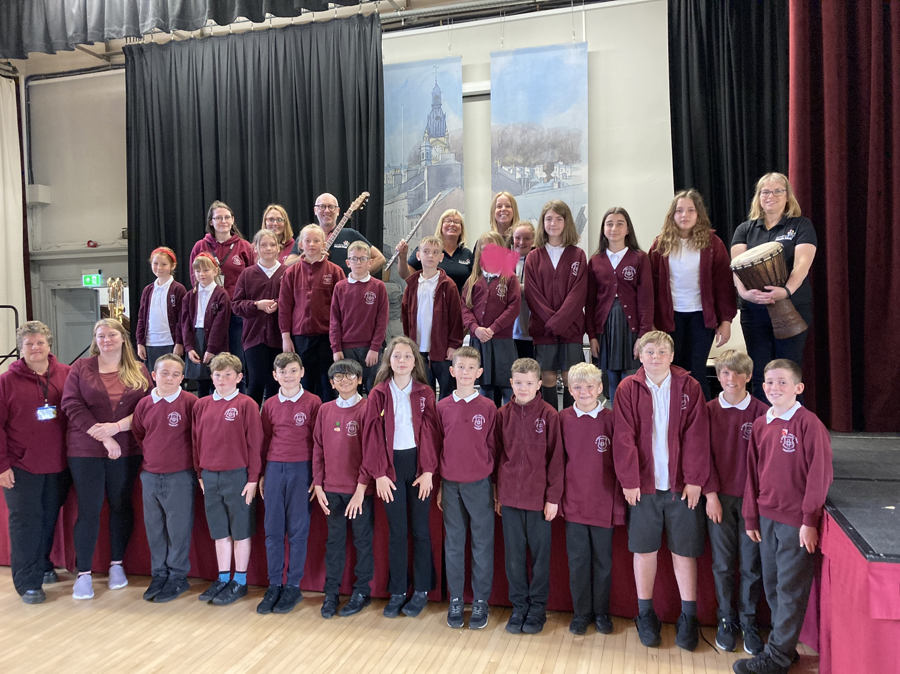

**DIARY - KEY DATES:**

**Monday 6th June – School reopens**

**Wednesday 8th June – Sports Day**

**Friday 10th June – Class Photos**

**Thursday 30th June – Westmorland County Show**

**Hope you all have a lovely weekend!!**

**Wrap-around Care** - all payments are due in advance when booking please

Breakfast Club is open from 8.15am until 8.45am £2 per child, per session

After-school Club* runs from 3.15pm until 5.15 pm at £4 per child, per session.

*Please book a week in advance to allow staff planning. If less notice is given we cannot guarantee availability.

Reception 66%

Year 1 100%

Year 2 92%

Year 3 70%

Year 4 100%

Year 5 75%

Year 6 92%

**Head Teacher’s Comments**

Dear Parents and Carers,

Half term is here! I can't believe how quickly the year is going.

We have had a lovely week in school. Yesterday, Year 6 enjoyed a very welcomed treat at Cafe Italia. Thank you as ever to Cafe Italia for their generosity and kindness. The children and staff thoroughly enjoyed their treats.

Yesterday morning, the whole school joined Father Bernard and the Parish for mass to celebrate the feast of the Ascension. As ever, the children showed immense respect and reverence.

This morning KS2 performed in The Big Sing with Cumbria Music Hub at Kendal Town Hall. The theme of this years Big Sing was 'Save our planet'. As ever, we were extremely proud of the children and are so happy to be back performing with other local schools.

We hope you all enjoyed the PFAs Jubilee tea party after school today. Our PFA work tirelessly to organise events and fundraisers to raise money for our children, for which we are very grateful. The PFA (Parents and Friends) are always looking for new members to join.

Weather permitting; sports day is on Wednesday 8th June. As usual, we will be holding sports day at Windermere Rugby club, from 9.30am. Parents and Carers are welcome to come and support. We may need helpers to walk to and from the rugby club. If you think you might be able to help, please see Mrs Bone.

Good luck to the Explorers whose potatoes are being judged in Saturdays County Show...

School reopens on Monday 6th June; we look forward to seeing you then.

Enjoy the break,

Mrs Bone and Mrs Tansey

Stay safe,

Mrs Bone and Mrs Tansey

Mrs Bone and Mrs Tansey

Head of School & Executive Head



WOW! Amazing, year 1 & 4. that’s fantastic!!

Keep

**ATTENDANCE TEDDY AWARD**

