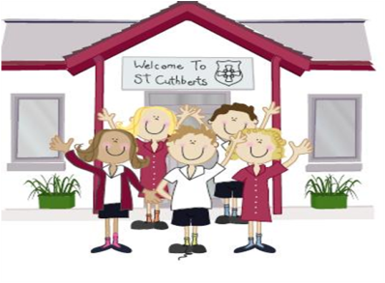333333333333 11th March 2022

FRIDAY NEWSLETTER

3rd

**DIARY – March 2021**

**Mon 14th & Wed 15th March** – Year 5’s forest school at Brockhole

**Mon 14th – Fri 18th March** – Year 5 / 6 – Bikeability in school

**Thur 17th March** – First Holy Communion preparation begins. 3.15 – 4.15 in school

**Thur 17th** – SATs booster (Year 6) club begins. 3.15-4.15 in school

**Mon 28th** – KS2 Brewery Dance. *Tickets available from the Brewery*

**Friday 17th December – School closed for Christmas.**

**Hope you all have a very merry Christmas!!!!**

**Wrap-around Care** - all payments are due in advance when booking please

Breakfast Club is open from 8.15am until 8.45am £2 per child, per session

After-school Club* runs from 3.15pm until 5.15 pm at £4 per child, per session.

*Please book a week in advance to allow staff planning. If less notice is given we cannot guarantee availability.

Reception 90%

Year 1 93%

Year 2 96%

Year3 95%

Year 4 94%

Year 5 92%

Year 6 94%

**Head Teacher’s Comments**

Dear parents and Carers,

We hope you are all keeping well and managing to stay safe.

Unfortunately, we have had a few cases of COVID within our school community. In an attempt to keep our school COVID free, we are kindly requesting that you test your child if they show any symptoms and follow the current guidance (on DOJOs). Thank you for continued your support.

We have had a wonderful week in school.  The children enjoyed *'Encanto'* at the Movie Night last night. Thank you to the PFA, who worked so hard to make the event so special for the children. The final total raised is set to be over £**100**. We are so lucky to have such an active and supportive PFA.

If you are interested in joining, please speak to Sally- Anne (Chair) or Mrs Osborne (Vice Chair).

Next week is very busy in school, *please keep an eye on the calendar for dates*. Year 5 and 6 have Bikeability in school all week; bikes and helmets can be left in school. Year 5's also have their forest school sessions at Brockhole on *Monday and Tuesday*.

On Friday we are joining other local Primary Schools at St. Martins and St. Mary's to celebrate Windermere Science week. The children will be meeting Professor Pumpernickel! We have a 'mind blowing' afternoon planned...

The Mini Police met this week with PCSO Sarah Blacow. We have a very exciting project in the pipeline. Watch this space...

Today we have spent the day thinking about how lucky we are. The children all wore yellow and blue in support of Ukraine and our cake sale was a massive success. We will let you know how much we have raised to help families in need, in Ukraine.  Thank you for your donated items too, Mrs Bone has delivered them to the drop off point. Please keep these families in your prayers.

We hope you all enjoy the weekend,

We hope you enjoy the weekend, stay safe,

Mrs Tansey  Mrs Bone

Executive Head Head of School.

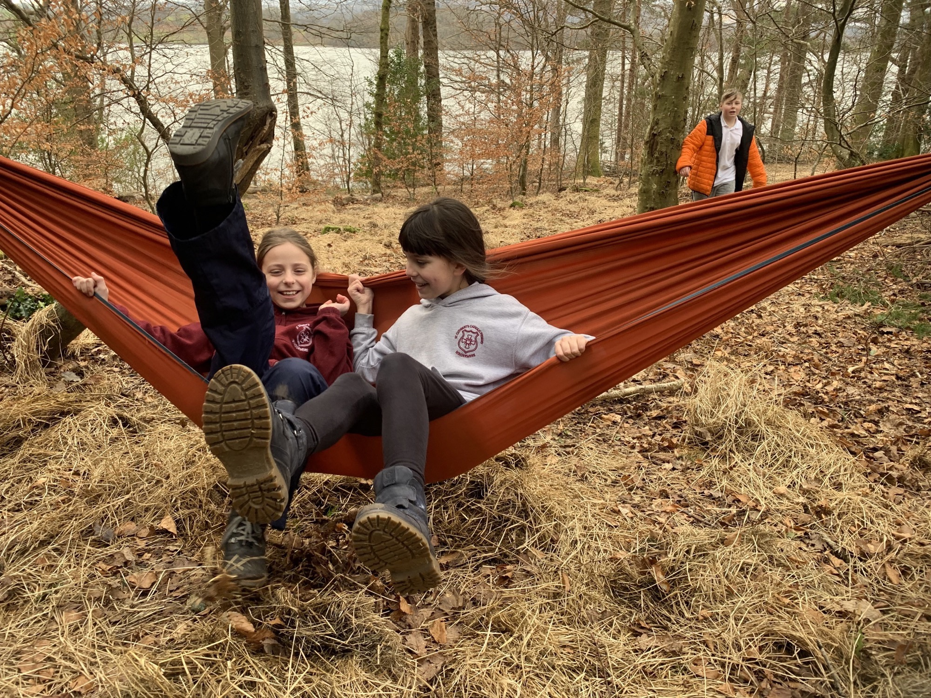



Mrs Bone and Mrs Tansey

Stay safe,

Mrs Bone and Mrs Tansey

Mrs Bone and Mrs Tansey

Head of School & Executive Head



**ATTENDANCE TEDDY AWARD**



Please stay safe well done all children for all your amazing work….